Annex 3 (+) to the AEL Agreement

Structure of the academic year, dates of exams and availability of marks

University: | Kaunas University of Technology
Academic year: | 2023/2023
University’s AEL co-ordinator(s): | Jurgita Motiejūnienė
Relevant websites: | https://en.ktu.edu/

Structure of the academic year: general description

The academic year is structured in two semesters (Fall and Spring), each comprised of 16 teaching weeks.
The Fall semester starts September 2 and ends around December 23. It is followed by the examination period from January 1 to the end of January. Resits take place in the last week of January.
The Spring semester starts February 1 and ends around May 31. It is followed by the examination period from June 1 to around June 31. Resits take place in the last week of June.
There is a one-week break for Christmas and a one-week break for Easter. The summer holidays are in July and August.

Key Dates

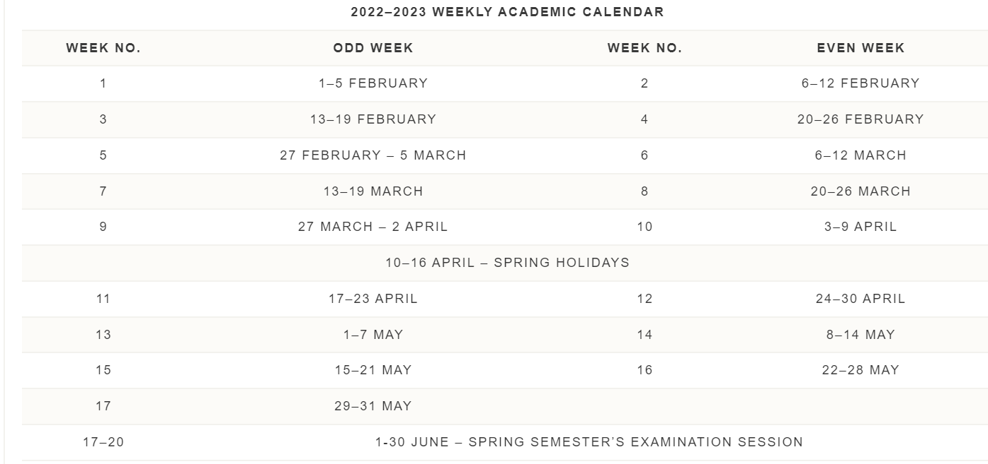

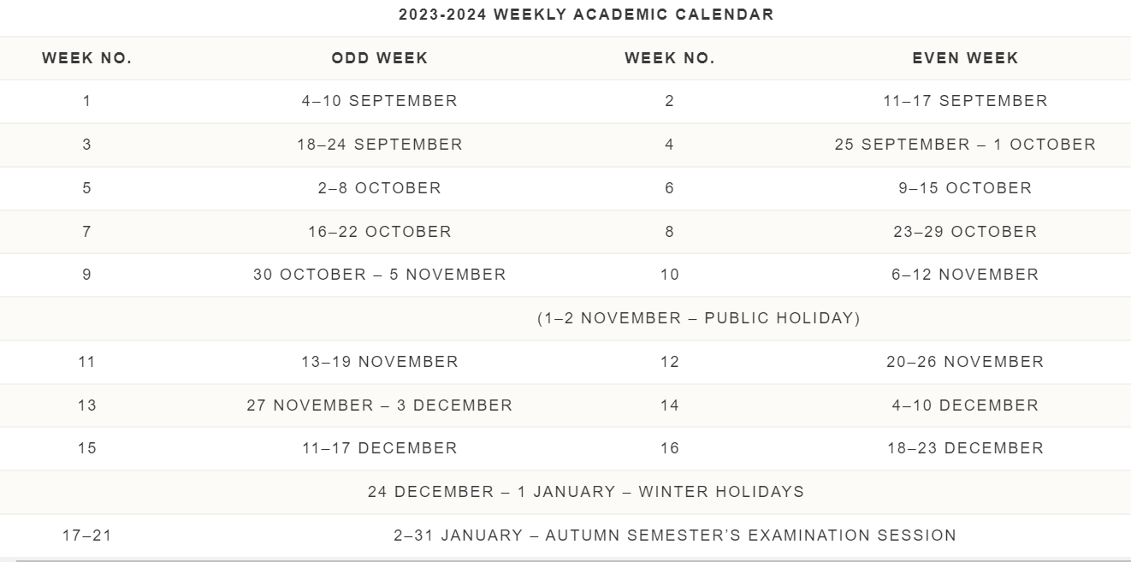

Availability of marks

First semester exams | By the end of January
Second semester exams | By the end of June
Re-sits | By the end of June

